FRONT END WEB DEVELOPMENT

CTEC 3905

P1319376x

GAZI MD. JAHID HOSSAN

Contents

**Introduction…………………………………………………………….3**

**First Website**

**General View…………………………………………..……..4**

**Technical review**

**HTML……………………………………………….…..5**

**CSS……………………………………………….………5**

**Java Script………………………………………….…6**

**Second Website**

**General View………………………………………….………7**

**Technical review**

**HTML…………………………………………..……….8**

**CSS…………………………………………….…………8**

**Java Script…………………………………………....9**

**Third Website**

**General View………………………………………………..11**

**Technical review**

**HTML………………………………………………..…12**

**CSS1…………………………………………………....12**

**Java Script……………………………………………12**

**Comparison among the websites…………………………....13**

**Conclusion……………………………………………………………...13**

**References……………………………………………………………...14**

**Introduction:**

A website can be described and segregated into many pieces. In this essay, my aim is to focus on front –end elements like HTML, CSS or JavaScript to realise its structure, design and layout. This will be achieved by the investigation on several websites, which involved websites structure, CSS controlled layout based on screen size and JavaScript interaction with websites elements.

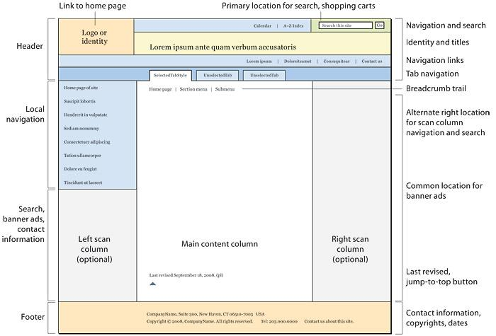As the web has developed over the decade, the web pages structure has become stable and predictable broadly in text-driven information sites. Despite all web pages do not follow the exact structure and features, most web pages associate some or all of these basic elements like logo, header, navigation, footer in specified locations that have turn into popular to web users according to Lynch and Horton (1999).

Figure 1: Standard website structure

**First Website:** [**www.evansfireplaces.com**](http://www.evansfireplaces.com)

**General View:**

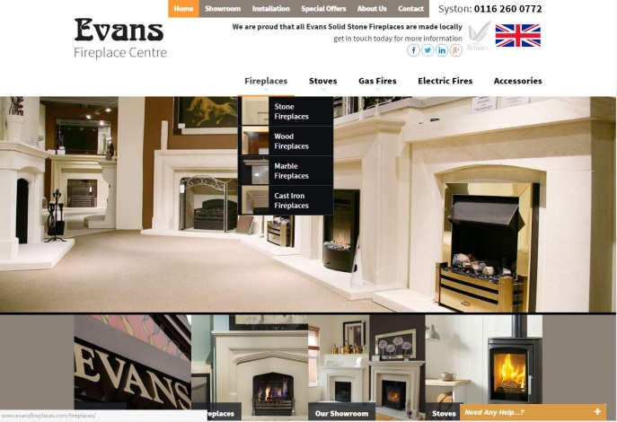If this is the standard way to develop a website, I think current website is not well structured and cluttered with images on the website. At the top of the Website, two pictures slide in repeatedly which is occupied whole screen and it changes very quickly, that makes displeasing reflection to the viewer. There have three navigation bars on the home pages, which lay out different section in a radically distinct way that only serve to confuse visitor. First, at the right at the top, second one just below the top navigation bar that is apparently navigates the gallery. Last one at the middle. In additionally, there have also quick link at the bottom of the page. It seems like website is not organised.

Figure 2: Evans fire place’s Front Page

The main purpose of this website is to provide needful information about the products and services to its targeted customer. This Website is entirely dynamic and made of series of pages. It does not facilitate with e-commerce or shopping cart neither promote to its customer to write blog or poll.

**Technical review:**

**HTML:**

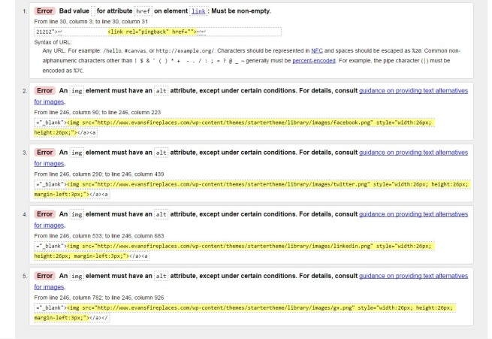I examined its source code and realised that website was written in HTML5. HTML code has been investigated and cross checked on W3 validator to find out any errors occurred during development period. Surprisingly, five errors found on its HTML codes in line 246 and 247. Those errors are not complicated but over sighted unfortunately. At the top of the page there have small icons of Facebook, Twitter, Linkedin and g+ which has been added into the webpage as an (png) image. An image element must have “alt” attribute but none of the images have “alt” value. As a result, it shows five errors in HTML code.

Figure 3: HTML Errors

There have two HTML form associated with “POST” method where customer can request the shop centre to call them back in their desirable time.

All of the images in this web site delivered from the server machine. However, video delivered through the video sharing website Vimeo.

It uses div element rather than Symantec HTML element “section”.

**CSS:**

Fifteen different css file manages this whole website. Responsive website can be surfed by all different kind of devices like Mobile, tablet and desktop. The number of mobile devices to surf the webpages is growing. Therefore, websites need to adapt the content based on the screen size or pixel resolution. This website is responsive. One of the important css file is responsive.css, which is liable to become the website responsive. It changes the layout of the website according the size of the screen. There have few CSS files, which control HTML elements. I figure out that responsive.css file control the HTML elements to resize, hide, shrink, enlarge, or move the content to make it look good on any screen. There have 10 break points on this site.

1. @media only screen and (max-width: 960px)
2. @media only screen and (max-width: 900px)
3. @media only screen and (max-width: 760px)
4. @media only screen and (max-width: 660px)
5. @media only screen and (max-width: 535px)
6. @media only screen and (min-width: 375px) and (max-width: 667px) and (orientation: landscape)
7. @media only screen and (min-device-width: 768px) and (max-device-width: 1024px) and (orientation: portrait) and (-webkit-min-device-pixel-ratio: 2)
8. @media only screen and (min-device-width: 768px) and (max-device-width: 1024px) and (orientation: landscape) and (-webkit-min-device-pixel-ratio: 1)
9. @media screen and (max-width:400px)
10. @media only screen and (max-width:400px)

As this website is responsive, it shows different layout based on the screen size. As a part of the website’s responsive layout its video can be watched only if the screen width is over 535px including landscape orientation. Therefore, video could be available in landscape orientation although video is hidden in portrait orientation. I discovered about the website that once video plays in landscape mode from any devices which width are over 535 pixels and thereafter if devices back into portrait orientation that video’s visibility responds to hide. Consequently, video will not be available whether the audio plays from the background that is a significant flaw. In addition, there have no control bar to mute or stop the audio until device orientation back to landscape and video’s visibility respond to visible.

**Java Script:**

JavaScript has been used to provide a dynamic view to this website. Large number of image sliders has been deployed which run by the support of JavaScript with various techniques. At the front page both image slider use JavaScript with association of standard libraries JQuery. Ajax manages front-page drop down menu with the linking Google APIs. At the accessories page JQuery handles external plugins FancyBox which is powerfull tools to display images in graceful way.

**Second website:** [**http://www.beedstudios.co.uk/**](http://www.beedstudios.co.uk/)

**General view:**

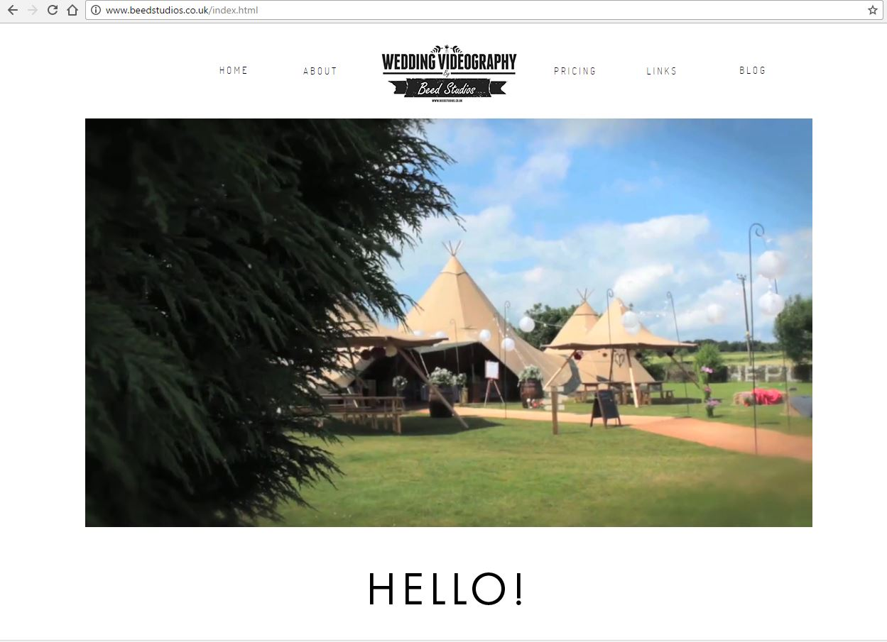Structure of the site is important part of the planning to outline the web elements, how information spread out across the pages: like chapters in a book. It provides practical functionality for the visitor to the site. (Whittaker, 2002) Particularly this website layout is simple and well structured. Its presentation and appearance is very elegant. Colour palette, layout and font have been used perfectly with the combination of overall styling and sounds.

Figure 4: Beed Studio’s Front page

A well-structured website does not simply existence of aesthetic pleasing interface, but it also effortless to navigate. The process to create an elegant website includes concentrate to navigation as well as pictures, videos and other design elements. Its Navigation is very straightforward and easy to find out required information quickly and easily. It implemented the same basic design, with common navigation buttons located in the same place but changes contents and elements in the different pages.

Beed Studios offers personal wedding films using expertise in videography, editing and graphic design that have developed through years of experience. The purpose of this website is to promote and provide information about the business services and products to its potential clients. It does not facilitate with e-commerce or shopping cart neither promote to its customer to create poll.

**Technical review:**

**HTML:**

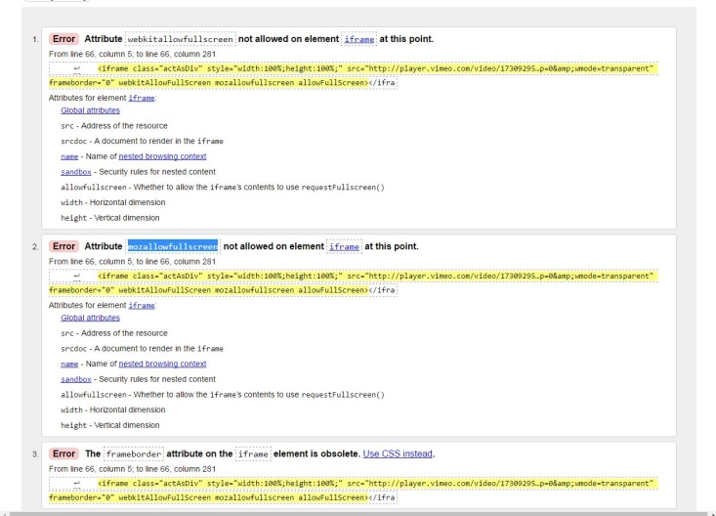Doctype specify version is HTML5. Its home page linked with four single pages named after about, links, pricing and blog. The entire site includes with same navigation bar. There have some technical issues with its HTML code. Three HTML errors has revealed while its code checked in W3 validator. Some of the attribute like “webkitallowfullscreen” and “mozallowfullscreen” are not allowed on element “iframe” at this point.

Figure 5: HTML Errors

Website content is mostly video and few images. All of the images supplied from the server machine and video from “Vimeo”.

This website is entirely static and made with series of pages.

It uses div element rather than Symantec HTML element “section”.

**CSS:**

The website appearance consolidates to one or a handful documents by using the Cascading Style Sheets (CSS) and substantially reduce the amount of time and work spent on a single document. (York, 2005)

There have three external CSS files to control HTML elements like paragraph, font, div, nav, h1, h2, h3, h4, h5, h6, background-colour etc.

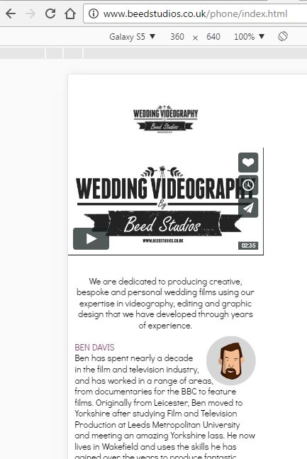This website is not responsive to the size of screen. However, if the screen size less than 370 px only then it forwards to mobile version which is single static page website. Mobile version available on <http://www.beedstudios.co.uk/phone/index.html>

Figure 6: Mobile Version

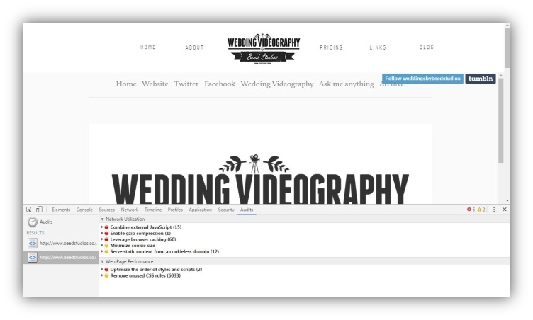**JavaScript:** JavaScript has been used to provide some functionality to this website. Five errors have been discovered and some technical issues in blog.html page.

Figure 7: java Script Errors

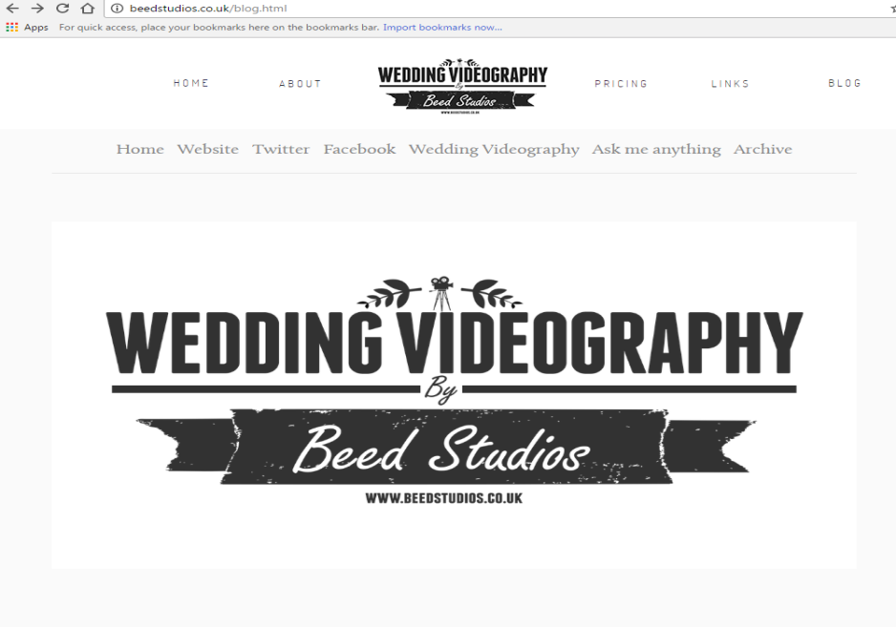In blog page, another sub navigation bar appears just like the picture above which includes seven buttons. “Website” is one of the buttons of that sub navigation bar. If I click on website button, it generates whole website again under the blog.html page and create 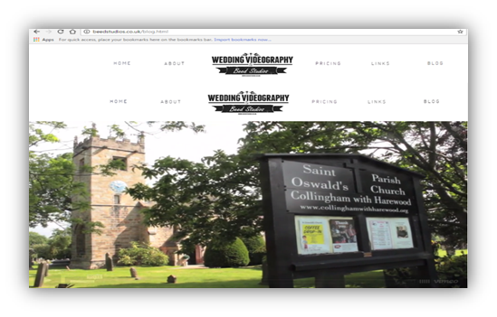double navigation bar at the top of the web site, which is not desirable.

Figure 8: blog.html page

Figure 9: Replication of whole website

**Third website:** [**http://www.leeja.co.uk/**](http://www.leeja.co.uk/)

**General view:**

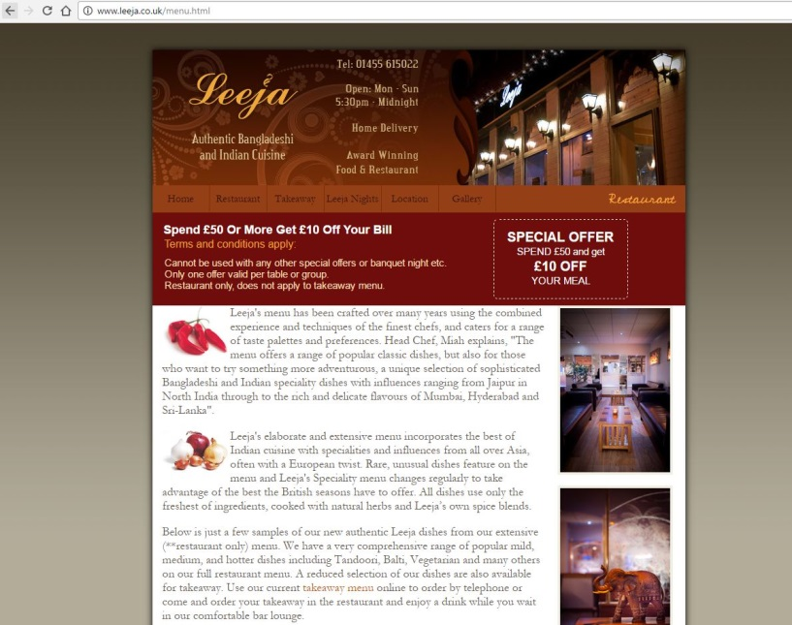Colour selection is an important step in the design process that is often over looked. Every colour and colour combination has a distinct set of meanings (McNeil, 2008). An example of good use of brown colour set up on the Leeja Restaurant site. This simple colour element connects with the purpose of the site, but more importantly, it reflects the appeal of the food available on the site colour.

Figure 10: Leeja’s Front Page

The main aim of this website is to promote and provide information about the business services and products to its potential clients. It does not promote e-commerce or shopping cart neither allow to its customer to create blog or poll. Leeja established in 1979, have been serving high quality Indian cuisine from restaurant in Hinckley now for over 30 years.

**Technical review:**

**HTML:**

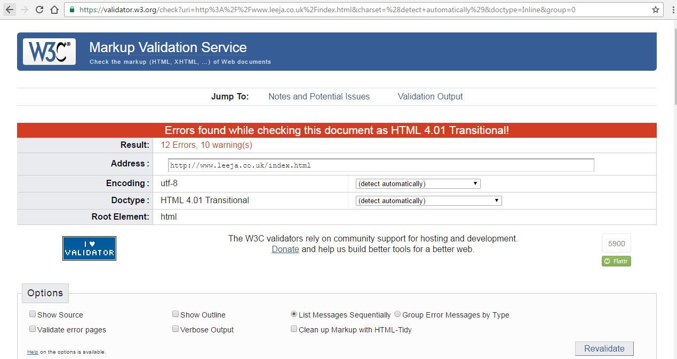Leeja home pages connected with five single pages. It implemented the same basic design, with common navigation buttons located in the same place at the top of the page but changes contents and elements in the different pages. Nevertheless, user could find it difficult to navigate the website without looking at the address bar, as there have no distinction on the navigation bar that provide information to the user which page is being used now. There have no DOCTYPE declaration in its HTML code. HTML code is not indent properly. It is good practice to use Symantec block level elements SECTION or asymantec elements DIV in BODY part. However, block level elements like TABLE has been used instead of DIV or SECTION. 12 HTML errors and 10 warnings come out while checked in W3C validator. Some of the errors are quite simple as if no value on alt attributes, no doctype declaration etc. All the images delivered from the server machine and there has no video in this site.

Figure 11:HTML Errors

**CSS :**

There has only one external CSS file name styleleeja.css that control HTML elements include background, table, title etc. It also uses Google API fonts which family is “Cedarville+Cursive”. This website is not responsive.

**Java Script:**

FancyBox is a tool that offers a nice and elegant way to add zooming functionality for images, html content and multi-media on webpages. It built on the top of the popular JavaScript framework JQuery. Fancy box used in index.html and gallery.html pages.

**Comparison among the websites:**

|  |  |  |  |
| --- | --- | --- | --- |
| **Criteria** | **Evans Fire Place** | **Beed studios** | **Leeja** |
| HTML | HTML5 | HTML5 | html |
| Responsive | Yes | No | No |
| Google Font API | Yes | No | Yes |
| Fancy Box Plugins | Yes | No | Yes |
| Phone version | No | Yes | No |
| Video Content delivered by | Vimeo | Vimeo | No |
| Colour combination | Black and white | Black and white | Brown |
| HTML Form elements | Yes | No | No |
| Blog | No | Yes | No |
| Navigation | Complex | Simple | Simple |
| HTML Errors | 5 | 3 | 12 |
| Responsive breakpoint | 10 | 0 | 0 |
| Map included | Yes | No | Yes |

**Conclusion:**

It is important to create websites that satisfy the required purposes, have a magnetic aesthetic and have a level of usability that makes it a suitable experience (Lawrence and Tavakol, 2007). Experts, users, and developers are recognising the value of aesthetics and usability in website design. Each website has a different level of usability and aesthetic requirements, based on the exact nature and purpose of the website. Therefore, in website development work, it is major awareness to coordinate the usability design thinking with the consideration of aesthetics and website purpose.

**References:**

Jason W. (2002) web production for writers and journalists.2nd ed. London,UK: Routledge

Richard Y. (2005) Beginning CSS: Cascading Style sheets for Web Design. Indiana, USA: Wiley Publishing, Inc.

Patrick M. (2008) The Web Designer’s Idea Book. Ohio,USA: HOW Books.

Dave L. Soheyla T. (2007) Balanced Website Design. London, UK: Springer-Verlag London Limited.

Web Style Guide. 3rd edition. [online]available on: <http://webstyleguide.com/wsg3/6-page-structure/3-site-design.html> [last accessed 11/11/2016]

Markup validation Service [Online] available at <https://validator.w3.org/> [last accessed11/11/2016]

Evans fire Place [online] available at <http://www.evansfireplaces.com/> [last accessed11/11/2016]

HTML [online] available at <http://www.w3schools.com/> [last accessed11/11/2016]

Beeds Studios [online] Available at: [http://www.beedstudios.co.uk/ [last](http://www.beedstudios.co.uk/%20%5blast) accessed11/11/2016]

Leeja [Online] Available at: <http://www.leeja.co.uk/index.html> [last accessed11/11/2016]

Wedding Videography Beed Studio<http://www.beedstudios.co.uk/phone/index.html> [last accessed17/11/2016]